Curriculum Vitae 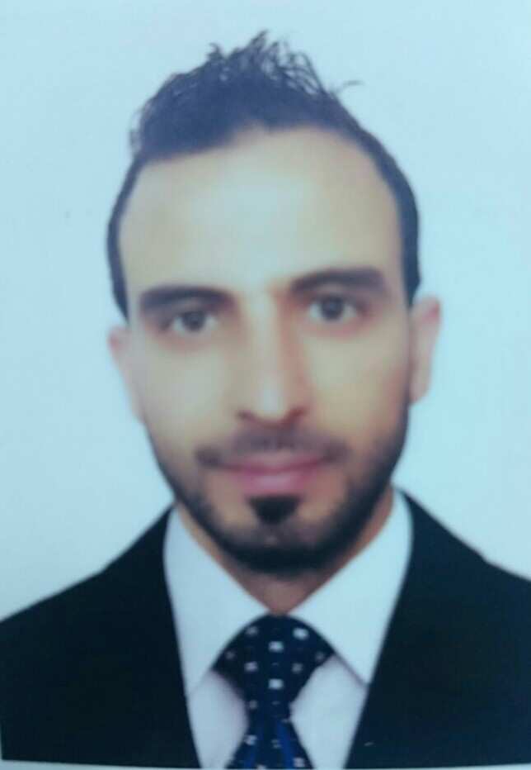

PERSONAL DETAILS

1- Name: MOHAMMAD HAMDAN AL KHALAF
2- Date of Birth: 04/02/1989
3- Address: SYRIA - DIER AL ZOOR
4- Married Status: Single
5-Currently Resident: Turkey – Sanliurfa
6- Phone Number (MOBILE): +905314952810

EDUCATIONS:

1-OIL TECHNIC INSTITUTE (TWO YEARS) SYRIA - ROMILAN -DRILLING SECTION
2-DIPLOMA IN OIL DRILLING (TWO YEARS) 2008 – 2010
3-ALFURAT UNIVERSITY –FACULTY OF EDUCATION 2014
4-DIPLOMA OF BUSINESS ADMINSTRATION OF LAHEYE UNIVERSITY
5-DIPLOMA OF HUMAN RESOURCES OF LAHEYE
6- ENGLISH BUSINESS BY AMERICAN UNIVERSITY – DELAWARE IN TURKEY

SKILLS AND COURSES:

1- Computer course ( MS Office + Internet )
2- Drilling Programs in rigs
3- English Course of ENGLISH TIME institute in Turkey-Shanliurfa

EXPERIENCES:

- Administrator in CAN Office (Sowren Interpreter )

- AL Chbisaa FIELD AS ASSISTANCE DRILLER -NATIONAL RIG 1500 E - FIVE YEARS

LANGUAGES:

1- ARABIC: NATIVE LANGUAGE
2- ENGLISH: FLUENT (WRITING – READING – CONVERSATION)
3-TURKISH: INTERMEDIATE

EMAIL: MHAMD.HM89@GMAIL.COM



